**WEEK-8**

1. **Git – HOL**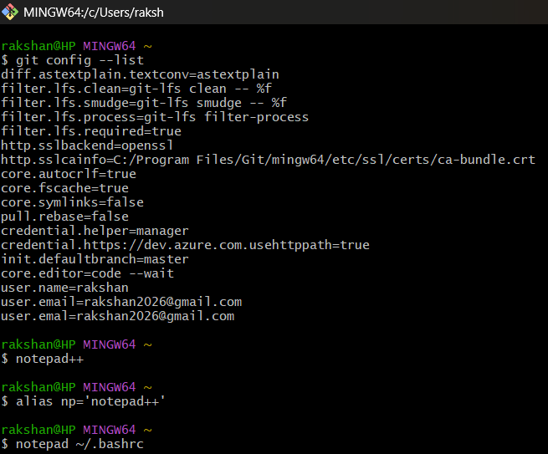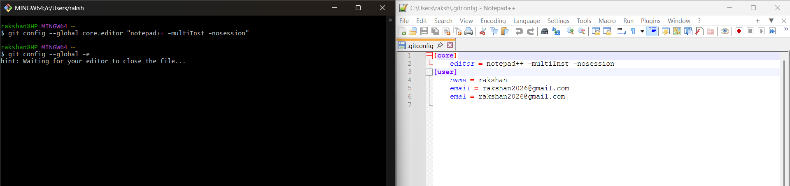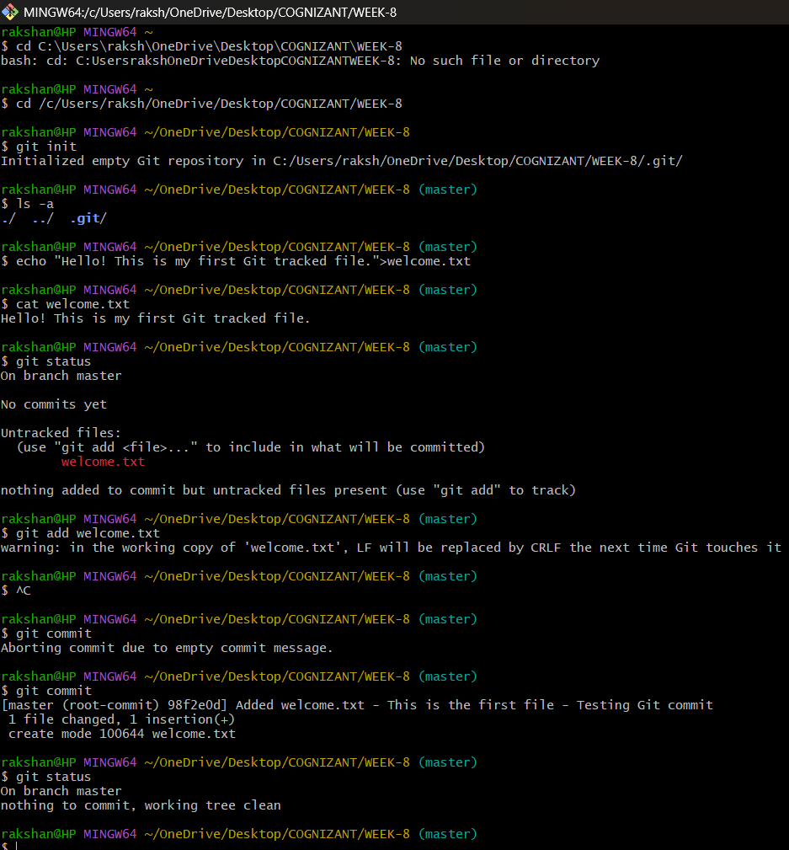

Signup with GitLab and create a remote repository “GitDemo”

In bash navigate to GitDemo, copy gitlab project url

To push the local to remote repository, execute : $ git push -u origin master

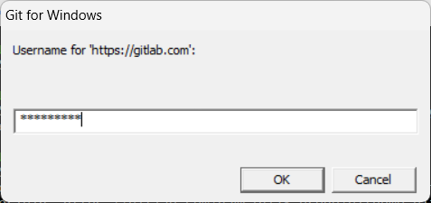

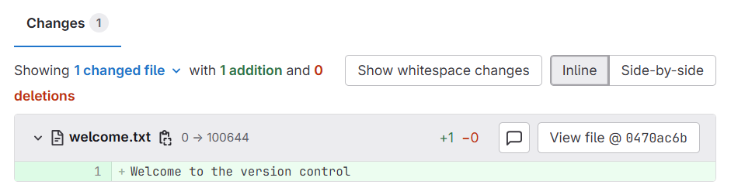

**Explanation:**

* Initialized a Git repository inside the WEEK-8 folder so that Git can start tracking changes in this project.
* Created a file named welcome.txt and confirmed its presence using git status, which showed it as an untracked file.
* Added the file to the staging area using git add welcome.txt, meaning Git is now ready to include it in the next commit.
* Saw a CRLF/LF warning, which is normal in Windows — it just means Git will adjust line endings automatically.
* Prepared for the first commit, which will save this file’s current version into the local repository so it becomes part of the project history.